Orwell Township
Spring Clean-Up Day
Saturday April 5th, 2025
9:00am-1:00pm

Orwell Township Building
619 South Hill Road
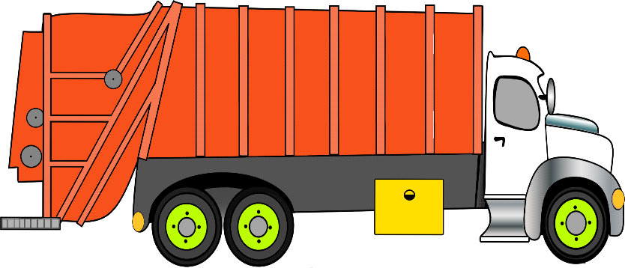

- Accepting CLEAN Tires, CASH or CHECK ONLY
Car and Pickup Truck Tires Only (Up to 22.5")
First 10 tires -$2.00 per tire
Any additional tires beyond the first 10 will cost $5.00 each
NO TRACTOR TIRES ALLOWED

- We will accept metals and appliances (except with Freon)
- Absolutely NO electronics will be accepted
- NO Construction materials will be accepted
- NO Shingles will be accepted
- NO Household Garbage

ORWELL TOWNSHIP RESIDENTS ONLY, PLEASE!
If you have any questions, call Mia 570-744-1388
www.orwelltwp.com

